|  |  |
| --- | --- |
|  | **FPT ACADEMY INTERNATIONAL**  **FPT – APTECH COMPUTER EDUCATION** |

**Centre Name: ACE-HCMC-2-FPT.**

**Address: 590 Cach Mang Thang 8, District 3, Ho Chi Minh City, Viet Nam.**

**CAR SHOWROOM**

|  |  |  |
| --- | --- | --- |
| **Supervisor:** | Mr. Ngo Phuoc Nguyen | |
| **Semester:** | II | |
| **Batch No:** | T1.2104.E0 | |
| **Group No:** | 1 | |
| **Order:** | **Full name** | **Roll No.** |
| 1. | Nguyen Quoc Khang | Student1313770 |
| 2. | Huynh Thanh Phat | Student1316205 |
| 3. | Le Anh Trung | Student1313756 |
| 4. | Dinh Toan Thinh | Student1316192 |

February 2021

**Table of Contents**

REVIEW 1 3

1. INTRODUCTION 4

2. EXISTING SCENARIO 4

3. CUSTOMER REQUIREMENT SPECIFICATION 5

4. FUNCTIONAL REQUIREMENT SPECIFICATION 6

5. SYSTEM REQUIREMENTS 13

6. DEVELOPMENT SOFTWARE 14

7. TECHNOLOGY 14

REVIEW 1 – TASK SHEET 15

**REVIEW 1**

# INTRODUCTION

Vin - Showroom is a website specialized in selling and introducing car of the most famous brand in VietNam - VinFast. We are constantly updating new model of car

Vin-Showroom has become one of the most trustworthy names for people who’re interested in car, especially Vinfast car. We are committed to make every customer have a best choice for a luxuary and convnience car. Our mission is always the trust and satisfaction of customers with what we bring.

# EXISTING SCENARIO

Instead, customers have to go to our real showroom to update information of car. Then just visit our website, customers can get all information of new models. Our consulting employee always ready to help customers .

Currently, due to the demand for. Therefore, Vin-Showroom website was created to serve the need of customers.

# CUSTOMER REQUIREMENT SPECIFICATION

* The website must allow customers who visit the site to browse and search for cars. They can compare cars.
* If the customer wishes to buy or need to know more information of car, they just fill a form. Register an account will be a better way, members will have premium customer service such as price, booking a consulting employee, present... A customer with an existing account can login. They do not have the permission to change any information apart from their own.
* Customers can review their order history in the "order history" section.
* At the homepage of the website, customers can find for information of car model. Also at the homepage, customers can easily see new models of our brands that have been and are about to be sold.
* The website must allow the admins (owner and employee who are appointed to the job) to view, update (when requirements are met) existing cars..
* An admin can to change sensitive information (e.g. delete, update a product,etc).
* Aside from managing products. An admin can also view reports on products, revenue, orders, order status and customers.

# FUNCTIONAL REQUIREMENT SPECIFICATION

## **User Can Register**

* 1. **Description**

Customers must be able to register a new account. Once they have their account, they can login and access more features. Althought a guest, who is not logged in,can order but they won’t have discount or order history.

* 1. **Functional Requirement**

User must provide the information below to create an account:

* Username
* Password
* Confirm password
* Citizen id
* Full Name
* Email
* Phone number
* Address

## **User Can Login**

* 1. **Description**

After registering an account, user can login. Once they have logged in, they can modify their personal information, including their password. They can also access more features: product review, order products, order history. Customer must provide Username (or alternatively their Email) and Password to login. Customer can login by authenticating by google or facebook (or both).

* 1. **Functional Requirement**

User must already have an existing account and it must not be a banned account. User must provide Email and Password to login.

## **User Can Search Products**

* 1. **Description**

User can search any infomation of car without logging in. If there is a car that corresponds to the keyword the user uses to search, the screen will be displayed for the user to see. Otherwise, there will be a "No result" message.

* 1. **Functional Requirement**

User do not need to be logged in to search for the car they are looking for. User can search any car they want by:

* Model names

## **User Can Order :**

* 1. **Description**

User can find cars they want by searching. User can orders by adding chosen cars to the order form. They will be asked to provide billing and payment information.

* 1. **Functional Requirement**

User must not log in to use this function. User can order products that are in stock and pre-order products if the product is temporarily out of stock. User needs to provide the information below to complete their order placement(if user is member infomation will autofill and confirm, employee will contact and confirm by phone):

Citizen id

Full Name

Email

Phone number

Address

## **User Can Write Reviews on Products**

* 1. **Description**

User can leave their review and rating on products. Each user can only post one review on each product. Rating can be done by choosing on a scale from 1 to 5, in which 5 is the best score. This score will be calculated and serve as the overall rating of the products.

* 1. **Functional Requirement**

User must login to use the review function. They must provide:

* Review title
* Review content
* A score on a scale from 1 to 5

## **User Can See Order History**

* + - * 1. **Description**

User can see their order history.

* + - * 1. **Function Requirement**
* User can review their order history.

## **Admin Can Manage employee account**

* 1. **Description**

The site must allow admins to manage the order, member, employees and income statement, warehouse..

Employer can create a new account of employee.

* 1. **Function Requirement**

To create a new employee account, employer must provide:

* Employee user name.
* Password.
* Email.

Other requirements:

* Must login as an admin to create a new account.
* Names are unique
* Admin can delete employee account.

## **Admin Can Manage Car’s Details (Images, Attributes)**

* 1. **Description**

The site must allow admins to interact with Products’ Details. An admin can view a list of attributes of a product. Admin can modify a car’s attributes like adding and removing attributes. An admin can also see customers’ rating and reviews on a product and can response to customer’s review.

* 1. **Function Requirement**

To modify a car’s details, admin must provide:

* Specific product
* Attributes
* Attribute Groups
* Admin’s response to a review

Other requirements:

* Must login as an admin to add or modify cars
* Attributes must exist
* When modify a car’s details, modified date can be recorded

## **Admin Can Manage Customers**

* 1. **Description**

The site must allow admins to interact with Customer’s Accounts. When a customer has registered an account, they will show up in customer list. An admin can view a list of existing registered customers. Admin can ban a customer who violates site’s rules by changing customer’s status.

* 1. **Function Requirement**
* Must login as an admin to ban customers
* Admin can search customers by Username, Phone and Emails
* Admin can filter customers by registered date and status
* Admin can ban customers
* Admin must provide: customer’s Active status

## **Admin Can Manage Orders**

* 1. **Description**

The site must allow admins to interact with Orders. When a customer places an order, it will show up in the list of orders and these orders’ details. An admin can view a list of existing orders and see their statuses. Admin can change order status. Orders are considered highly important data and cannot be deleted.

* 1. **Function Requirement**

An Order will contain:

* Customer ID
* Name
* address
* phone
* date
* Status: Pending, Confirmed, Completed, Cancelled

Other requirements:

* Must login as an admin to modify order’s status
* Order must show created date
* Order must show updated date
* Admin can search orders by customers
* Admin can filter customers by created date

## **Admin Can Manage Admin’s profile**

* 1. **Description**

Employer(super admin) can view a list of employees. employer cannot be deleted.

Employee can update their own infomation except id, email.

* 1. **Function Requirement**

To add or modify employees’ information, Super Admin must provide:

* Admin ID (for reference, cannot be changed)
* Username
* Password
* Role: Admin

To add or modify employees’ own information,employee must provide:

* Username
* Password

Other requirements:

* Usernames are unique
* When create an account, created date can be recorded
* When modify an account, modified date can be recorded
* Can search admins by id, usernames and roles

## **Admin Can Manage Reports**

* 1. **Description**

The site must allow admins to view reports of Products, Customers and Orders. Product report shows products by their sold quantity, the revenue of each individual product and allows admins to see which products need to be improved (low sale). Customer report shows customer’s activities such as the number of new customers, their orders and how much money a customer has spent. Order report shows the number of orders that have been placed and the revenues. Admin can export reports as a pdf file. Admin can also view the general report.

* 1. **Function Requirement**
* Must login as an admin to use report function
* Product: revenue for each product, revenue by category
* Order: total number of orders, total revenue
* Customer: total number of customer, customer’s activities

# SYSTEM REQUIREMENTS

## **Hardware**

|  |  |  |
| --- | --- | --- |
|  | SERVER | |
| Minimum | Recommended |
| Processor | 800 MHz Intel Pentium III | 2.6 GHz Intel Pentium IV |
| Memory | 2 GB | 4 GB |
| Disk space | 8 GB | 16 GB |
| Monitor | Super-VGA (800x600) or higher resolution monitor | |
| Internet | Internet access is required | |
|  | CLIENT | |
| Processor | 800 MHz Intel Pentium III | |
| Memory | 512 MB | |
| Monitor | Super-VGA (800x600) or higher resolution monitor | |
| Internet | Internet access is required | |

## **Software**

|  |  |
| --- | --- |
|  | SERVER |
| Operating System | Windows 8 or later |
| Browser | Google Chrome 65.0 |
| Database | MySql s |
| Software | Visual Studio Code 1.61.2. |
| Xampp 8.0.12/PHP 8.0.12 |
|  | CLIENT |
| Operating System | Windows 8 or later |
| Browser | Google Chrome 65.0 |

# DEVELOPMENT SOFTWARE

* Microsoft Windows 10
* Visual Studio Code 1.61.2
* MySQl
* Google Chrome 65.0

# TECHNOLOGY

* PHP
* MySql
* HTML
* CSS
* Jquery
* Laravel

**REVIEW 1 – TASK SHEET**

|  |  |  |  |  |  |
| --- | --- | --- | --- | --- | --- |
| No. | Contents | Member | Activity Plan | Preparation | |
| Start Date | Actual Days | Status |
| 1 | Introduction | Nguyễn QUốc Khang,Huỳnh Thành Phát, Lê Anh Trung, Đinh Toàn Thịnh | 09/02/2022 | 09/02/2022 | Done |
| 2 | Existing Scenario |
| 3 | Customer Requirement Specification |
| 4 | Functional Requirement Specification |
| 5 | System Requirements |
| 6 | Development Software |
| 7 | Technology |

**REVIEW 2**

## **1**

# Use Case and Sequence Diagram

## **User**

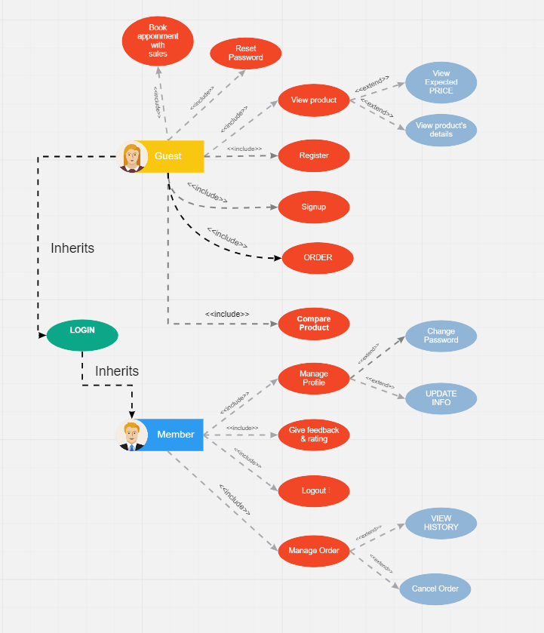

### Register as Customer

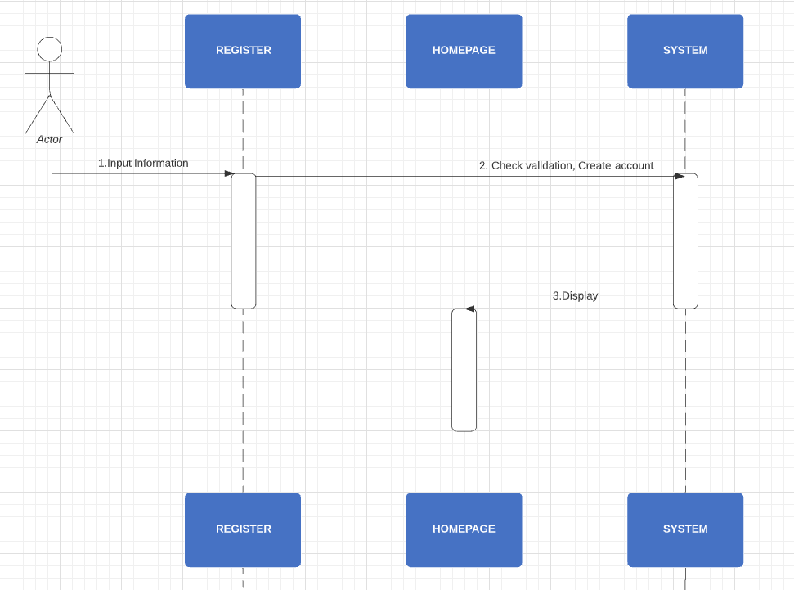

|  |  |  |
| --- | --- | --- |
| **Author** | Le Anh Trung | |
| **Use Case Name** | Register as Customer | |
| **Actors** | Guest | |
| **Description** | Guest registers an account on the website and becomes a member (customer) | |
| **Requirements** | Guest provides their register information | |
| **Pre-conditions** | N/A | |
| **Post-conditions** | Success: Guest creates a Customer account in this website | |
| Fail: Refill information | |
| **Basic flow** | **Actor’s actions:** | **System’s responses:** |
| 1. Actor clicks ‘Create Account’ link on Sign In Page.   3. Actor inputs register’s information and click ‘Register’ button. | 2. System redirects to Register page and displays Registration form with the following controls:  - ‘Email’ text field  - ‘Citizen_ID’ text field  - ‘Full Name’ text field - ‘Password’ text field  - ‘Gender’ field  -‘DOB’ field - ‘Confirm Password’ text field - ‘Phone_number’ text field  - ‘Address’ text field - ‘Register’ button 4. System validates the information. 5. System inserts the account into database  6. System show success message. |
|
|
|
|
|
|
|
|
|
|
|
|
|
|
|
| **Exceptions** | **Actor’s actions:** | **System’s responses:** |
| 1. Actor left ‘Email text field blank.  2. Actor left ‘Email’ text field blank or input an invalid email address. 3. Username has already existed. 4. Actor left ‘Password’ text field blank. 5. Actor left ‘Confirm Password’ text field blank. 6. Password and confirm password don’t match. 7. Actor left ‘ Full Name’ text field blank. 8. Actor left ‘Phone’ text field blank. 9. Input phone is not numeric format or phone length is not between 10 and 11 characters. | System displays message to actor: 1. ‘Email cannot be blank’.  2. ‘Email is invalid’. 3. ‘This Username has already existed’. 4. ‘Password cannot be blank’’. 5. ‘Confirm Password cannot be blank’. 6. ‘Confirm Password does not match password.’ 7. ‘Full Name cannot be blank’. 8. ‘Phone is invalid’. 9. ‘The phone number should be numeric only and must be between 10 and 11 digits’. |

### Login as Customer

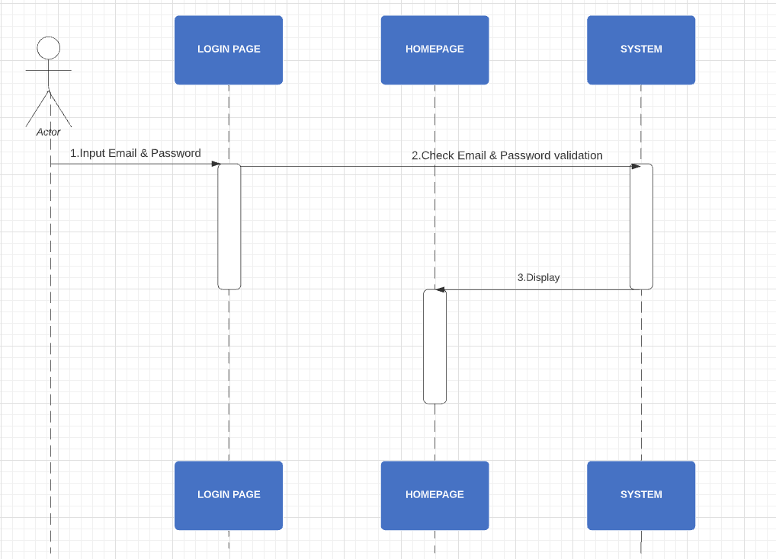

|  |  |  |
| --- | --- | --- |
| **Author** | Le Anh Trung | |
| **Use Case Name** | Login | |
| **Actors** | Customer | |
| **Description** | Customer who has registered an account can login | |
| **Requirements** | Customer provides email and password | |
| **Pre-conditions** | Customer who has registered an account can login | |
| **Post-conditions** | Success: User is logged in to website and redirect to HomePage/Current Page | |
| Fail: Refill information | |
| **Basic flow** | **Actor’s actions:** | **System’s responses:** |
| 1. Actor clicks on ‘Login’ button.     3. Actor inputs Email and Password, then click the ‘Login’ button. | 2. System redirects to Login Page with the following controls - 'Email' text field - 'Password' text field - 'Login' button 4. System checks the information. 5. System redirects to Homepage/current page |
|
|
| **Exceptions** | **Actor’s actions:** | **System’s responses:** |
| 1. Actor inputs invalid email or password. | System displays message to actor: 1.System shows message: “Invalid Email and password”. |

#### 1.1.2.1 Login with Google Authentication

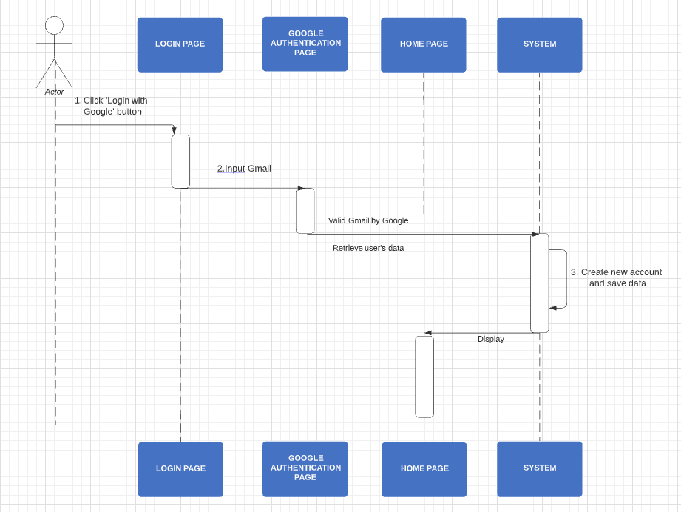

|  |  |  |
| --- | --- | --- |
| **Author** | Le Anh Trung | |
| **Use Case Name** | Login | |
| **Actors** | Guest | |
| **Description** | Guest can login page with their google account | |
| **Requirements** | Login page with their google account and become new customer | |
| **Pre-conditions** | Customer who has registered an account can login | |
| **Post-conditions** | Success: User is logged in to website and redirect to HomePage/Current Page | |
| Fail: Refill information | |
| **Basic flow** | **Actor’s actions:** | **System’s responses:** |
| 1. Actor clicks on ‘Login with Google’ button.     3. Actor inputs Gmail and Password, then click Sign in | 2. System redirects to Authention Page of Google with the following controls - 'Email' text field - 'Password' text field 4. System checks the information. 5. System redirects to Homepage/current page |
|
|
| **Exceptions** | **Actor’s actions:** | **System’s responses:** |
| 1. Actor inputs invalid email or password. | System displays message to actor: 1.System shows message: “Invalid Email and password”. |

### Update Customer’s Profile

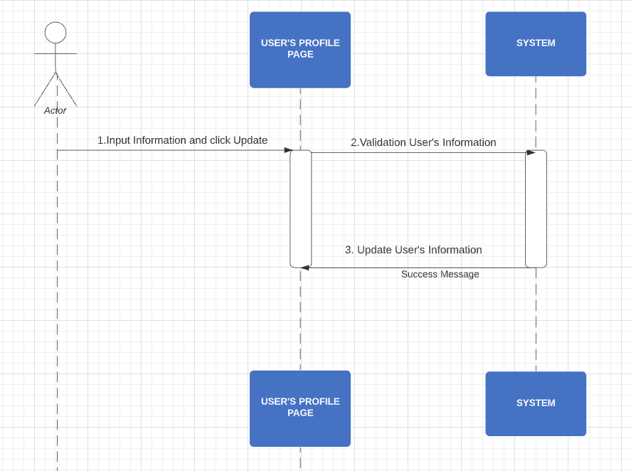

|  |  |  |
| --- | --- | --- |
| **Author** | Le Anh Trung | |
| **Use Case Name** | Update Customer’s Profile | |
| **Actors** | Customer | |
| **Description** | Customer wants to Update their profile’s information. | |
| **Requirements** | Actor provides profile information | |
| **Pre-conditions** | Actor has logged in. | |
| **Post-conditions** | Success: Profile’s information of this user has been updated. | |
| Fail: Refill information | |
| **Basic flow** | **Actor’s actions:** | **System’s responses:** |
| 1. Actor clicks ‘Update Profile’ button in Actor’s Profile menu.              3. Actor updates information and click ‘Save’ button. | 2. System redirects to Actor’s Profile page and displays Update Profile form with the following controls :  -‘Citizen ID’ text field - ‘Full Name’ text field - ‘Gender’ radio button  - ‘DOB’ field  - ‘Address’ text field - ‘Phone’ text field - ‘Email’ text field - ‘Save’ button - ‘Cancel’ button 4. System checks the information. 5. System updates the account in database and show success message then redirects to User’s Dashboard |
|
| **Exceptions** | **Actor’s actions:** | **System’s responses:** |
| 1. Actor left ‘Name’ text fields blank. 2. Actor left ‘DOB field blank. 3. Actor left ‘Address’ text field blank. 4. Actor left ‘Phone’ text fields blank. 5. Input phone is not in numeric or phone length is not in between 10 and 11 characters. 6. Actor left ‘Email’ text field blank or input an invalid email address. | System displays message to actor: 1. ‘Name cannot be blank’. 2. ‘Birthday is invalid’. 3. ‘Address cannot be blank’. 4. ‘Phone is invalid’. 5. ‘The phone number should be numeric only and must be between 10 and 11 digits’. 6. ‘Email is invalid’. |

### Change Customer’s Password

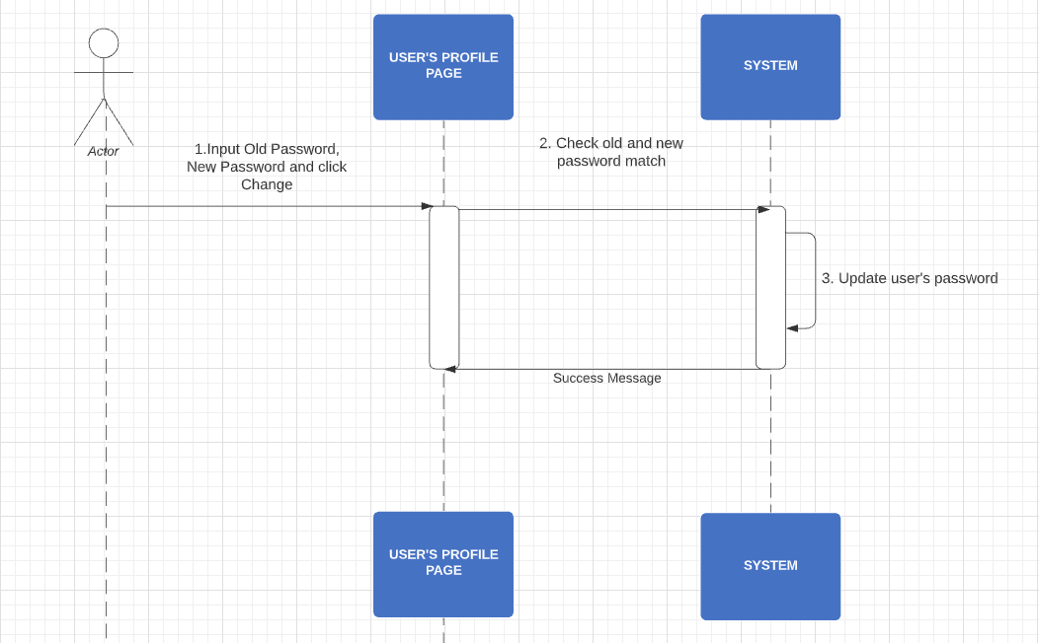

|  |  |  |
| --- | --- | --- |
| **Author** | Le Anh Trung | |
| **Use Case Name** | Change Customer’s Password | |
| **Actors** | Customer | |
| **Description** | Customer wants to change their password | |
| **Requirements** | Actor provides old password. | |
| **Pre-conditions** | Actor has logged in. | |
| **Post-conditions** | Success: The new password of this user has been updated. | |
| Fail: Refill information | |
| **Basic flow** | **Actor’s actions:** | **System’s responses:** |
| 1. Actor clicks ‘Change Password’ button in Update Profile Page (in Actor’s Dashboard).  3. Actor updates new password and click ‘Change’ button. | 2. System redirects to ‘Change Password’ page and displays Change Password form with the following controls : -‘Old password ’ text field.  -‘New password’ text field.  ‘New password confirm’ text field - ‘Change’ button - ‘Cancel’ button 4. System checks the information. 5. System updates the account’s password in database and show success message then redirects to User’s Dashboard |
|
| **Exceptions** | **Actor’s actions:** | **System’s responses:** |
| 1. Actor left Old Password/New Password text field blank. 2. Actor left ‘Confirm Password’ text field blank. 3. . New Password and New Password Confirm do not match. | System displays message to actor: 1. ‘Password cannot be blank’’. 2. ‘Confirm Password can’t be blank’. 3. ‘Confirm password does not match Password.’. |

### 1.1.5 Book Appointment with Dealer

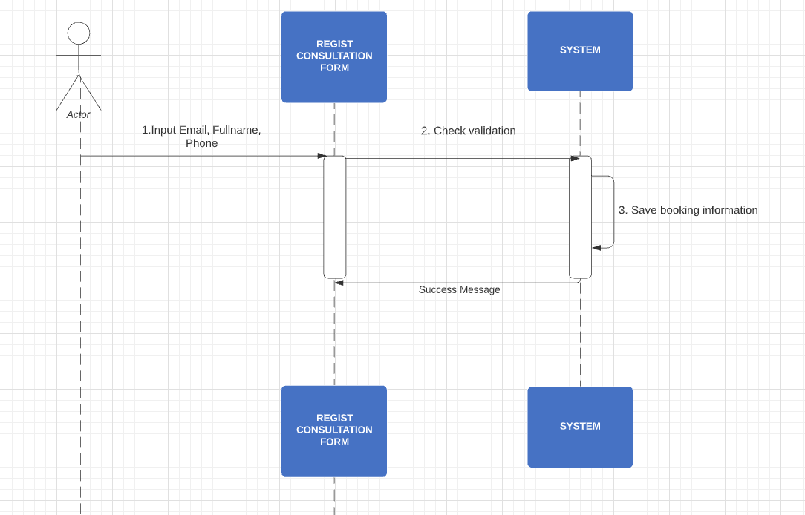

|  |  |  |
| --- | --- | --- |
| **Author** | Le Anh Trung | |
| **Use Case Name** | Regist for consultation | |
| **Actors** | Customer/Guest | |
| **Description** | Actor want to be registered for consultation | |
| **Requirements** | N/A | |
| **Pre-conditions** | N/A | |
| **Post-conditions** | Success: A consultation request is sent to the system | |
| Fail: Refill information | |
| **Basic flow** | **Actor’s actions:** | **System’s responses:** |
| 1. Actor clicks ‘Registered For Consultation’ button in All Page     3. Actor fill information and click ‘Submit’ button. | 2. System pop up ‘Registered For Consultation’ form with the following controls : -‘Full name ’ text field.  -‘Email text field.  -‘Phone’ text field - ‘Submit’ button 4. System checks the information. 5. System save the information of request into database and show success message. |
|
| **Exceptions** | **Actor’s actions:** | **System’s responses:** |
| 1. Actor left ‘Full name’text field blank. 2. Actor left ‘Email’ text field blank.  3.Actor use invalid email. | System displays message to actor: 1. ‘Fullname cannot be blank’’. 2. ‘Email can’t be blank’. 3. ‘Email invalid’ |

### 1.1.5 View Expected Price

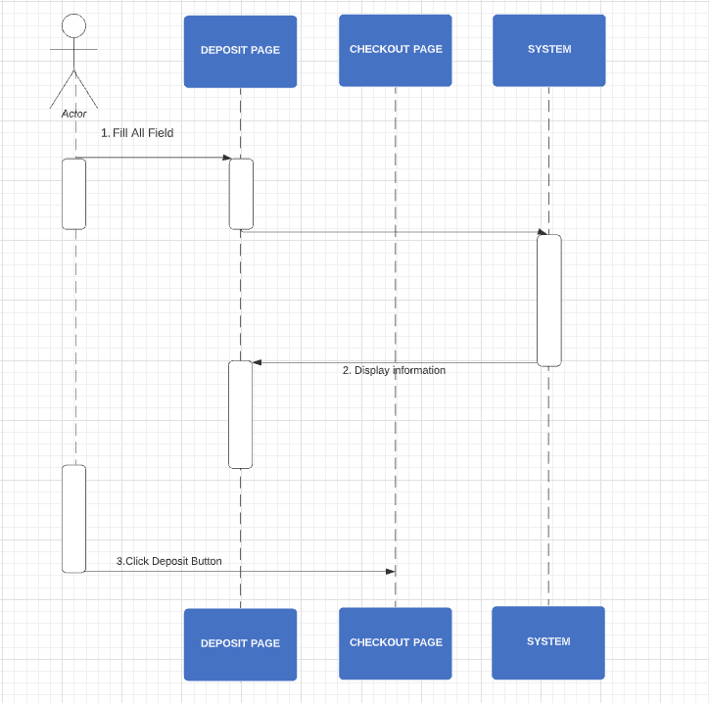

|  |  |  |
| --- | --- | --- |
| **Author** | Le Anh Trung | |
| **Use Case Name** | View Expected Price | |
| **Actors** | Customer/Guest | |
| **Description** | Actors want to view Expected Price | |
| **Requirements** | N/A | |
| **Pre-conditions** | N/A | |
| **Post-conditions** | Success: Display expected price page | |
| Fail: N/A | |
| **Basic flow** | **Actor’s actions:** | **System’s responses:** |
| 1. Actor clicks ‘View Expected Price’ link on navbar  3. Actor fill information with selection box. 5. Actor click ‘Deposit’ button. | 2. System redirects ‘View Expected Price’ page with the following controls :  -‘Car’s Image’ field.  -‘ Listed price ‘ field.  -‘Model Car’ field.  -‘Version’ field. - ‘Province’ field.  -‘ Registration fee 1’ field.  -‘ Registration fee 2’ field.  -‘ License plate registration fee’ field.  -‘Road maintenance fees’ field.  -‘Expected Price’ field.  - ‘Deposit’ button. 4. System show data from database and display to actors. 6. An order request send to system redirect to checkout page. |
|
| **Exceptions** | **Actor’s actions:** | **System’s responses:** |
| 1.Actor left all field blank. | 1.’No information display’. |

### 1.1.7. View car details (user)

|  |  |  |
| --- | --- | --- |
| **Author** | Huynh Thanh Phat | |
| **Use Case Name** | View car details | |
| **Actors** | Customer/Guest | |
| **Description** | Actor want to see car-details | |
| **Requirements** | N/A | |
| **Pre-conditions** | N/A | |
| **Post-conditions** | Success: Redirect to ‘Show all cars’ page | |
| Fail: N/A | |
| **Basic flow** | **Actor’s actions:** | **System’s responses:** |
| 1. Actor clicks ‘View car details’ link | 2. Redirect to ‘Car details’ page: |
|
| **Exceptions** | **Actor’s actions:** | **System’s responses:** |
| N/A | N/A |

### Compare products as Guest

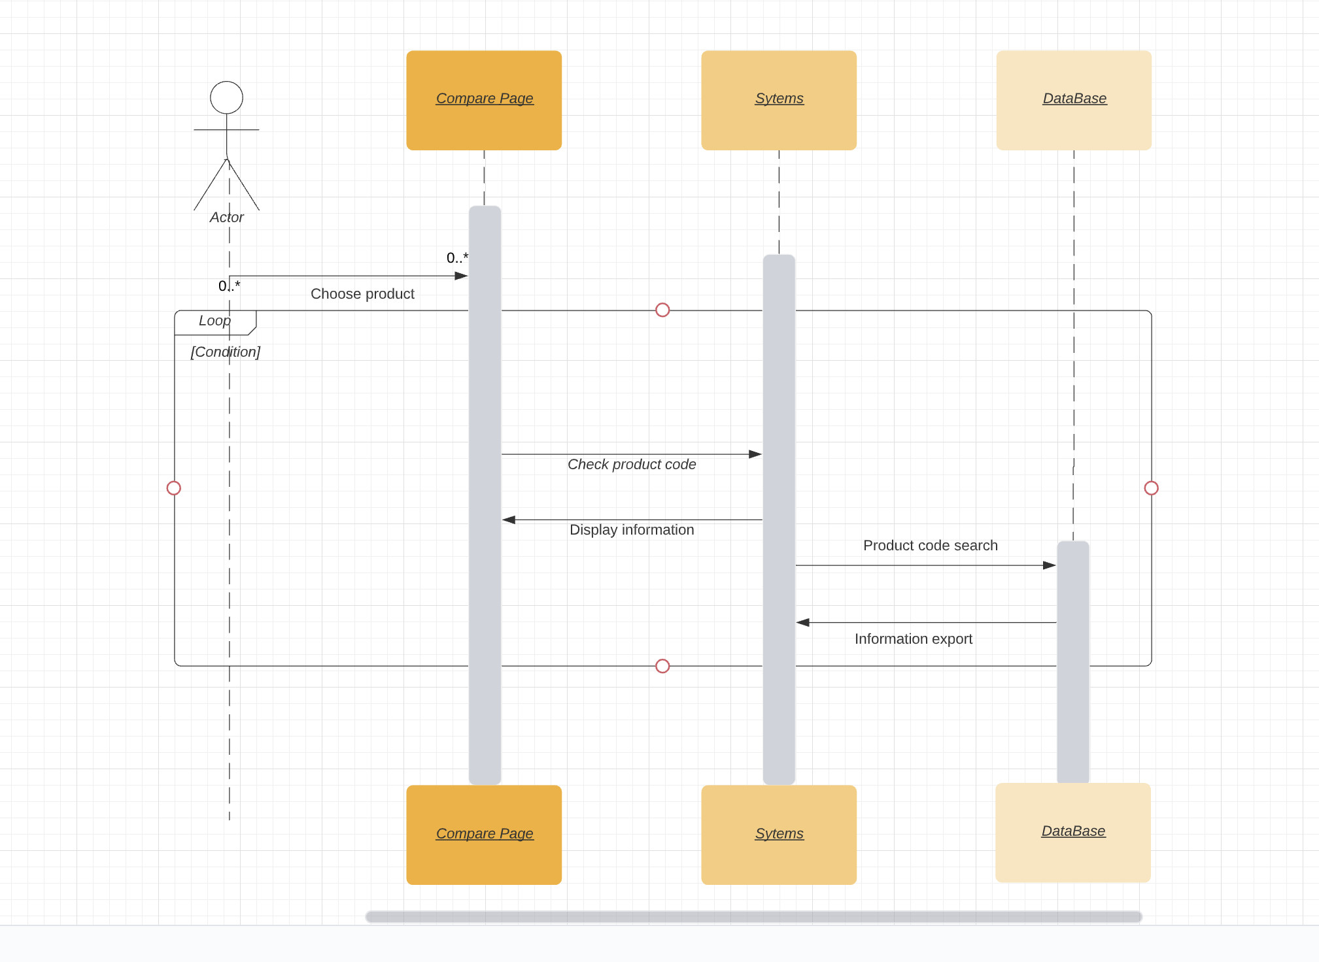

|  |  |  |
| --- | --- | --- |
| **Author** | Dinh Toan Thinh | |
| **Use Case Name** | Compare products as Guest | |
| **Actors** | Guest | |
| **Description** | Customers choose the product they want to compare to find the product they like | |
| **Requirements** | N/A | |
| **Pre-conditions** | N/A | |
| **Post-conditions** | Success: information is displayed | |
| Fail: Check the transmission | |
| **Basic flow** | **Actor’s actions:** | **System’s responses:** |
| 1. Customer selects the "Lựa Chọn Xe" box on the menu bar          3. Customers click on the magnifying glass icon to select the products they want to compare.  5. Customer clicks on the box Oder | 2. System redirects to Compare page and show page selections.  4. The page displays product information  6. The modal export system fills in purchase registration information |
|
|
|
|
|
|
|
|
|
|
|
|
|
|
|
| **Exceptions** | **Actor’s actions:** | **System’s responses:** |
|  | N/a | N/a |

### Compare products as Member



|  |  |  |
| --- | --- | --- |
| **Author** | Dinh Toan Thinh | |
| **Use Case Name** | Compare products as member | |
| **Actors** | Customer | |
| **Description** | Customers see the products they compare and can place orders right away | |
| **Requirements** | Customer login | |
| **Pre-conditions** | Requires login before ordering | |
| **Post-conditions** | Success: The user goes to the confirmation page and has an email to send a report on the registered mail | |
| Fail: check the transmission | |
| **Basic flow** | **Actor’s actions:** | **System’s responses:** |
| 1. Customer selects the "Lựa Chọn Xe" box on the menu bar  3. Customers click on the magnifying glass icon to select the products they want to compare.  5. Customer clicks on the box Oder | 2. System redirects to Compare page and show page selections  4. The page displays product information  6. The system redirects to the order page |
|
|
| **Exceptions** | **Actor’s actions:** | **System’s responses:** |
| N/a | N/a |

## **Admin**

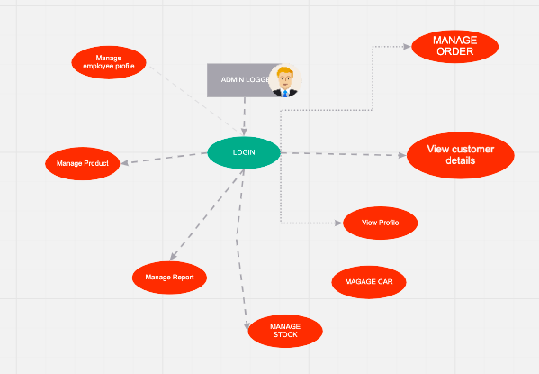

b.Dealer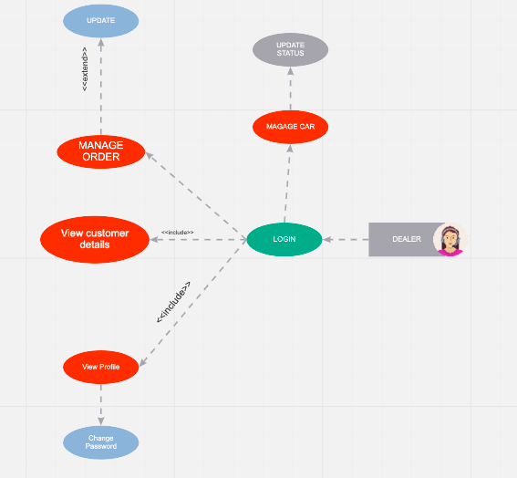

c. Warehouse employee

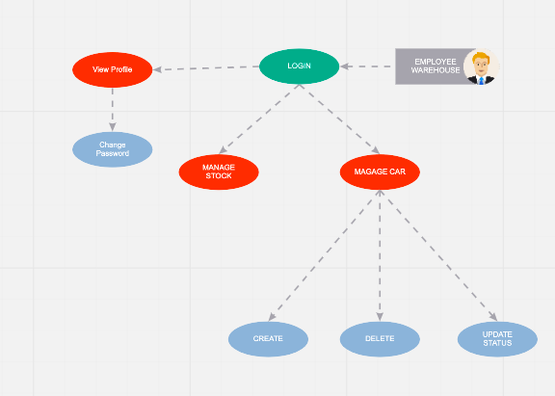

### Admin’s Account

1. **Add employee’s Account**

|  |  |  |
| --- | --- | --- |
| **Author** | Nguyen Quoc Khang | |
| **Use case name** | Add employee’s accounts | |
| **Actors** | Administrator | |
| **Description** | When admin wants to add a new employee’s account in the database | |
| **Requirements** | Admin provides admin information | |
| **Pre-conditions** | Actor is logged in as a Admin(super admin) | |
| **Post-conditions** | Success: a new admin(employee)’s account is created in the database | |
| Fail: Refill information | |
| **Basic flow** | **Actor’s actions:** | **System’s responses:** |
| 1. Actor chooses Admin Tab on menu.  3. Actor chooses ‘Create an Admin Account’ button.  5. Actor inputs information to create admin. | 2. System redirects to 'Admin List' page and display a list of existing admin.  4. System displays admin form with the following fields. - Admin’s Username - Admin’s password  - Confirm password - Admin’s role  6. System validates inputs.  7. System adds new admin to database.  8. System displays confirmation message. |
| **Exceptions** | **Actor’s actions:** | **System’s responses:** |
| 1. Actor left ‘Username’ field blank.  2. Actor inputs an existing Username.  2. Actor left ‘Password’ field blank.  3. ‘Confirm password’ does not match ‘Password’. | System displays messages: - ‘Username’ cannot be blank’.  - ‘Username already exists’ - ‘Password cannot be blank’.  - ‘Confirm password does not match password’ |
|
|

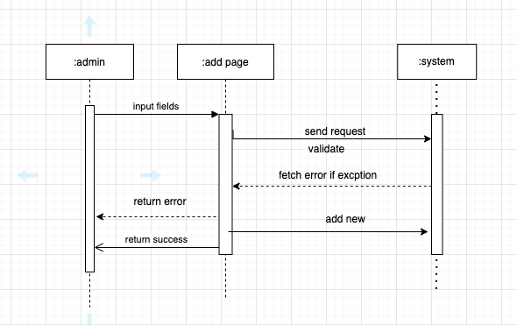

1. **Update Admin (by Super admin)**

|  |  |  |
| --- | --- | --- |
| **Author** | Nguyen Quoc Khang | |
| **Use case name** | Update admin’s accounts | |
| **Actors** | Administrator | |
| **Description** | When admin wants to update a employee’s account in the database | |
| **Requirements** | Admin provides admin information | |
| **Pre-conditions** | Actor is logged in as a Admin | |
| **Post-conditions** | Success: employee’s account is updated in the database | |
| Fail: Refill information | |
| **Basic flow** | **Actor’s actions:** | **System’s responses:** |
| 1. Actor chooses Admin Tab on menu.  3. Actor chooses Admin they want to update.  5. Actor inputs information to update admin. | 2. System redirects to 'Admin List' page and display a list of existing admin.  4. System displays admin form with the following fields. - Admin’s password  - Confirm password - Admin’s role  6. System validates inputs.  7. System updates admin in database.  8. System displays confirmation message or error message. |
| **Exceptions** | **Actor’s actions:** | **System’s responses:** |
| 1. Actor left ‘Username’ field blank.  2. Actor inputs an existing Username.  2. Actor left ‘Password’ field blank.  3. ‘Confirm password’ does not match ‘Password’. | System displays messages: - ‘Username’ cannot be blank’.  - ‘Username already exists’ - ‘Password cannot be blank’.  - ‘Confirm password does not match password’ |

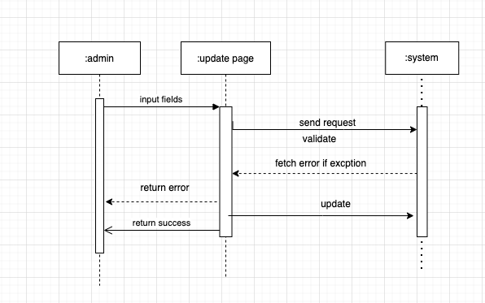

**c. Update admin’s profile**

|  |  |  |
| --- | --- | --- |
| **Author** | Nguyen Quoc Khang | |
| **Use case name** | Update admin’s profile | |
| **Actors** | Administrator | |
| **Description** | When admin wants to update their own profile in the database | |
| **Requirements** | Admin provides admin information | |
| **Pre-conditions** | Actor is logged in as a Admin | |
| **Post-conditions** | Success: employee’s profile is updated in the database | |
| Fail: Refill information | |
| **Basic flow** | **Actor’s actions:** | **System’s responses:** |
| 1. Actor chooses My profile Tab on menu.  3. Actor chooses update profile.  5. Actor inputs information to update. | 2. System redirect to profile page and display a admin profile.  4. System displays admin form with the following fields. - Admin account(read only) - Admin’s department(read only)  -Name  -Age  -Address  -Phone  -Branch  6. System validates inputs.  7. System updates admin in database.  8. System displays confirmation message or error message. |
| **Exceptions** | **Actor’s actions:** | **System’s responses:** |
| Artor left “Name” blank | System displays messages: - ‘Username’ cannot be blank’.  -If any feild(except Name) blank, auto fill “N/A” |



**d.Dealer take customer’s order**

|  |  |  |
| --- | --- | --- |
| **Author** | Nguyen Quoc Khang | |
| **Use case name** |  | |
| **Actors** | Dealer | |
| **Description** | After customer order car, dealer will see and take a order,then double check and confirm with customer, change a status field in table order detail in database. From order->checked->confirmed. When 1 dealer checked order, only that dealer can see the order detail. | |
| **Requirements** | Customer order. | |
| **Pre-conditions** | Actor is logged in as a Admin(dealer) | |
| **Post-conditions** | Success: order status field change. | |
| Fail: try again and submit. | |
| **Basic flow** | **Actor’s actions:** | **System’s responses:** |
| 1. Actor chooses Admin Tab on menu.  3. Actor chooses customer’s order Tab.  5. Actor change order’status. | 2. System redirects to 'Customer’s Order' page and display a list of ordering- customer’s Order.  4. System displays admin form with the following fields. -Customer information:  -Name.  -Phone.  -Email.  - Order infomation:  -Car model.  -Quality.  -Order status.  6. System displays error message. |
| **Exceptions** | **Actor’s actions:** | **System’s responses:** |
| 1. When two dealer check same order. | System displays messages: - ‘Some thing wrong! Order may be taked!’ |

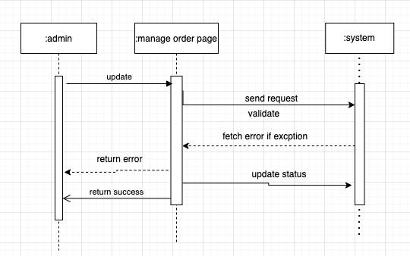

**e.Warehouse release car.**

|  |  |  |
| --- | --- | --- |
| **Author** | Nguyen Quoc Khang | |
| **Use case name** |  | |
| **Actors** | Warehouse | |
| **Description** | After dealer confirm order change a status field in table order detail in database.Warehouse can see the car model ordered. Warehouse make a car id and send to showroom. | |
| **Requirements** | Order with status confirmed. | |
| **Pre-conditions** | Actor is logged in as a Admin(WH) | |
| **Post-conditions** | Success: new car id. | |
| Fail: try again and submit. | |
| **Basic flow** | **Actor’s actions:** | **System’s responses:** |
| 1. Actor chooses Warehouse tab,“Car ordering tab”.  3. Actor chooses “Model detail”.  5. Actor create a new car infomation. | 2. System redirects to 'Car orderd List' page and display a list of ordering car  .4. System displays car form with the following fields.  -Car model.  -Quality.  -Showroom(branch).  -Stock.  6. System displays error message. |
| **Exceptions** | **Actor’s actions:** | **System’s responses:** |
| 1. When stock number smaller than quality | System displays messages: - ‘Not enough car in warehoue!’. |



**f.Warehouse confirm car to showroom.**

|  |  |  |
| --- | --- | --- |
| **Author** | Nguyen Quoc Khang | |
| **Use case name** |  | |
| **Actors** | Warehouse | |
| **Description** | After warehouse send car to showroom. Car status will be pending.When showroom recieved car, warehouse will change car status to “showroom” in table car info in database. | |
| **Requirements** | Car info’s status pending. | |
| **Pre-conditions** | Actor is logged in as a Admin(WH) | |
| **Post-conditions** | Success: car status change. | |
| Fail: try again and submit. | |
| **Basic flow** | **Actor’s actions:** | **System’s responses:** |
| 1. Actor chooses Warehouse tab,“Car tab”.  3. Actor chooses “Car detail”.  5. Actor change a car status. | 2. System redirects to 'Car List' page and display a list of car  .4. System displays car form with the following fields.  -Car id.  -Car status.    6. System displays error message. |
| **Exceptions** | **Actor’s actions:** | **System’s responses:** |
|  |  |



**g.Warehouse delete car id .**

|  |  |  |
| --- | --- | --- |
| **Author** | Nguyen Quoc Khang | |
| **Use case name** |  | |
| **Actors** | Warehouse | |
| **Description** | After showroom confirm cancel order. order status will be cancel.When warehouse recieved car back, warehouse can be delete car id in table car info in database and quarity field in stock table will increase. | |
| **Requirements** | Car info’s status customer cancel. | |
| **Pre-conditions** | Actor is logged in as a Admin(WH) | |
| **Post-conditions** | Success: car id deleted. | |
| Fail: try again and submit. | |
| **Basic flow** | **Actor’s actions:** | **System’s responses:** |
| 1. Actor chooses Warehouse tab,“Car tab”.  3. Actor chooses “Delete Car”.  5. Actor delete. | 2. System redirects to 'Car cancel List' page and display a list of car with status cancel.  .4. System confirm delete request.  6. System displays error message. |
| **Exceptions** | **Actor’s actions:** | **System’s responses:** |
|  |  |

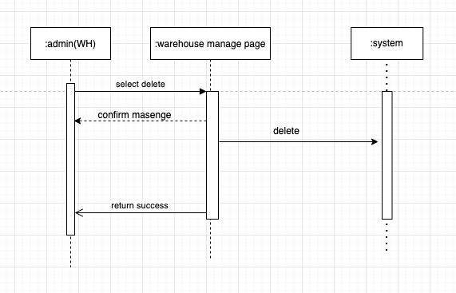

**g. Create new car model**

|  |  |  |
| --- | --- | --- |
| **Author** | Huynh Thanh Phat | |
| **Use case name** | Create new car model | |
| **Actors** | Administrator | |
| **Description** | When admin wants to create a new car model in the database | |
| **Requirements** | Admin provides car-model’s attributes | |
| **Pre-conditions** | Actor logged in as an Admin | |
| **Post-conditions** | Success: a new car-model is created in the database | |
| Fail: Refill information | |
| **Basic flow** | **Actor’s actions:** | **System’s responses:** |
| 1. Actor chooses ‘Create new model’ button.  3. Actor fill all fields. | 2. System displays ‘Create new car-model’ form with all car’s attributes 4. System validates input fields.  5. System adds new car-model into database.  6. System displays confirm message. |
| **Exceptions** | **Actor’s actions:** | **System’s responses:** |
| 1. Actor left one field blank.  2. Actor inputs an existing car-model. | System displays messages: - ‘All fields must be filled’  - ‘Model already existed’ |
|
|

**g. Search car model by model ID**

|  |  |  |
| --- | --- | --- |
| **Author** | Huynh Thanh Phat | |
| **Use case name** | Search car model by model ID | |
| **Actors** | Administrator | |
| **Description** | When admin wants to search car model by model ID | |
| **Requirements** | Actor enters model ID | |
| **Pre-conditions** | Actor logged in as an Admin | |
| **Post-conditions** | Success: show all results | |
| Fail: enter model ID again | |
| **Basic flow** | **Actor’s actions:** | **System’s responses:** |
| 1. Actor enters model ID into search field. | 2. System displays all result models. |
| **Exceptions** | **Actor’s actions:** | **System’s responses:** |
| 1. Actor entered an ID that did not exist in database. | System displays messages: - ‘No result’ |
|
|

**g. Update car model**

|  |  |  |
| --- | --- | --- |
| **Author** | Huynh Thanh Phat | |
| **Use case name** | Update car model | |
| **Actors** | Administrator | |
| **Description** | When admin wants to update car model | |
| **Requirements** | Actor updates model’s attributes | |
| **Pre-conditions** | Actor logged in as an Admin | |
| **Post-conditions** | Success: model’s attributes updated in database | |
| Fail: enter again | |
| **Basic flow** | **Actor’s actions:** | **System’s responses:** |
| 1. Actor clicks ‘Update’ button.  3. Actor update model’s attributes. | 2. System displays ‘Update model’ page.  4. System validates input fields.  5. System update model in database.  6. System displays confirm message. |
| **Exceptions** | **Actor’s actions:** | **System’s responses:** |
| N/A | N/A |
|
|

**g. Delete car model**

|  |  |  |
| --- | --- | --- |
| **Author** | Huynh Thanh Phat | |
| **Use case name** | Delete car model | |
| **Actors** | Administrator | |
| **Description** | When admin wants to delete car model | |
| **Requirements** | Actor clicks delete button | |
| **Pre-conditions** | Actor logged in as an Admin | |
| **Post-conditions** | Success: model deleted in database | |
| Fail: N/A | |
| **Basic flow** | **Actor’s actions:** | **System’s responses:** |
| 1. Actor clicks ‘delete’ button.  3. Actor clicks ‘Ok’ button. | 2. System displays confirm message ‘Are you sure you want to delete?’.  4. System delete model in database. |
| **Exceptions** | **Actor’s actions:** | **System’s responses:** |
| N/A | N/A |
|
|

# Entity Relationship Diagram (ERD)

## **2.1 Logical ERD**

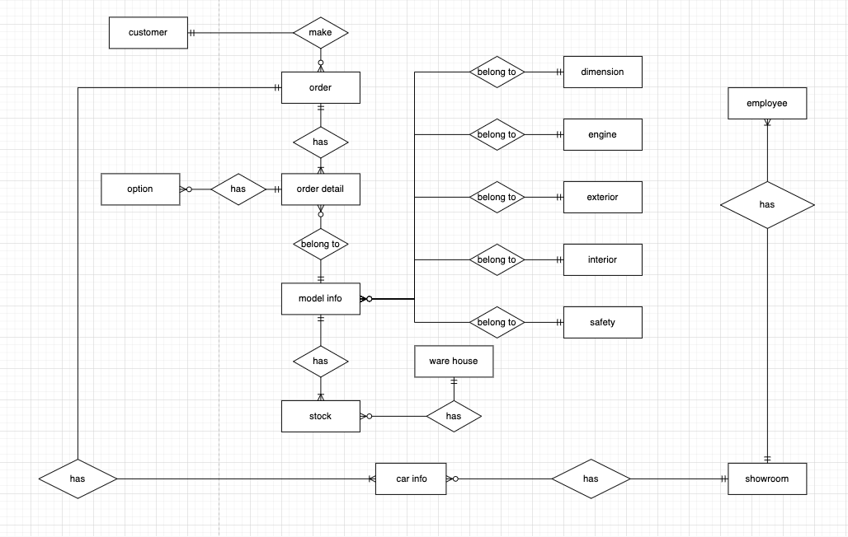

* 1. **Physical ERD  
     phat copy dtb vao dum**

**3.Data flow diagram**

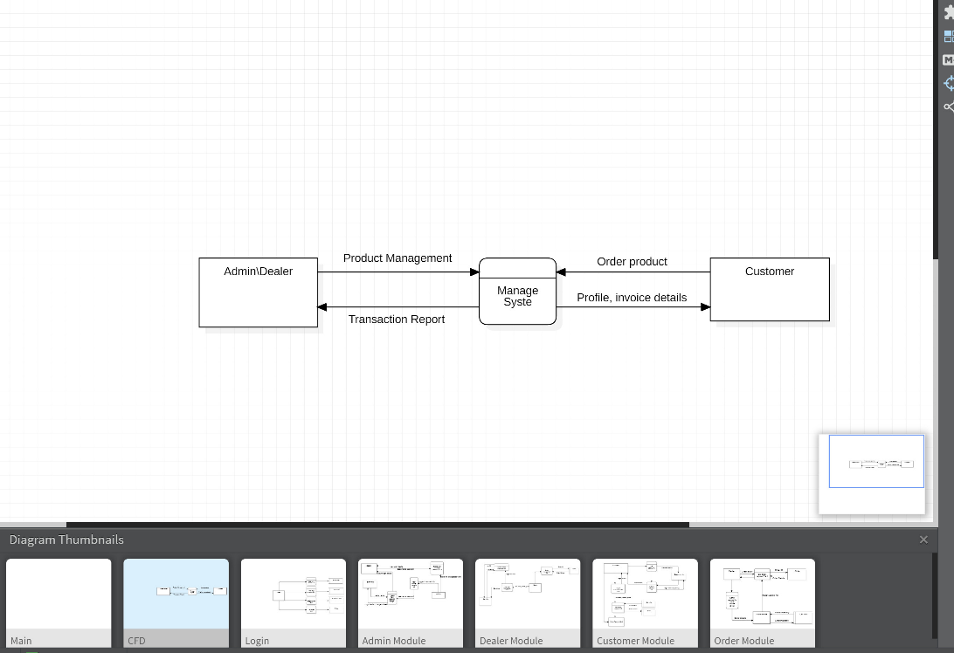 **3.1 CFD**

**3.2 Login Module**

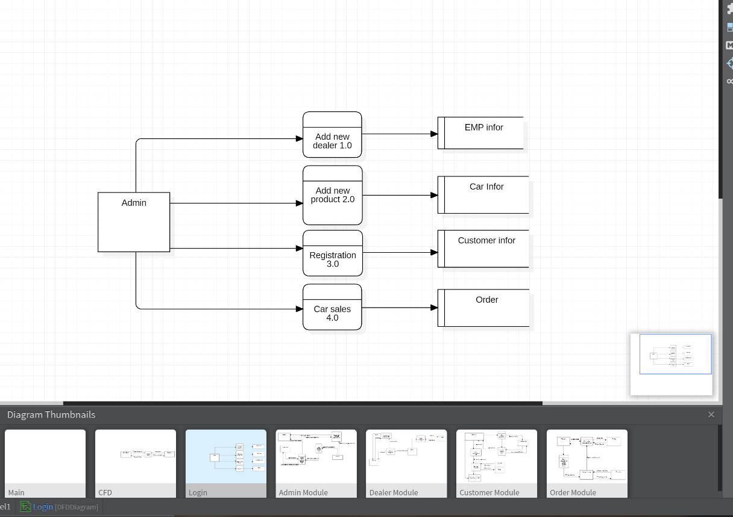

**3.3 Admin Module**

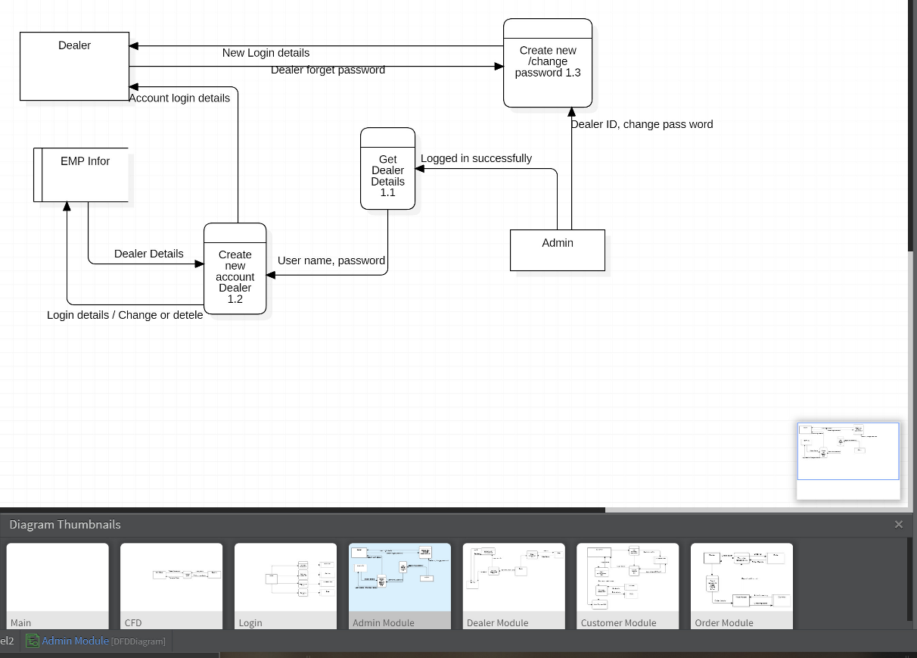

**3.4 Dealer Module**

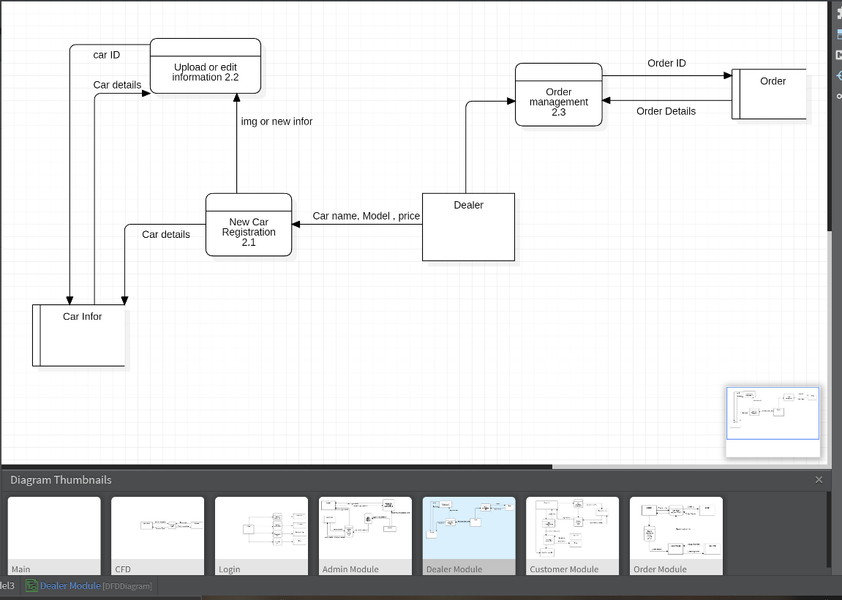

**3.5 Customer Module**

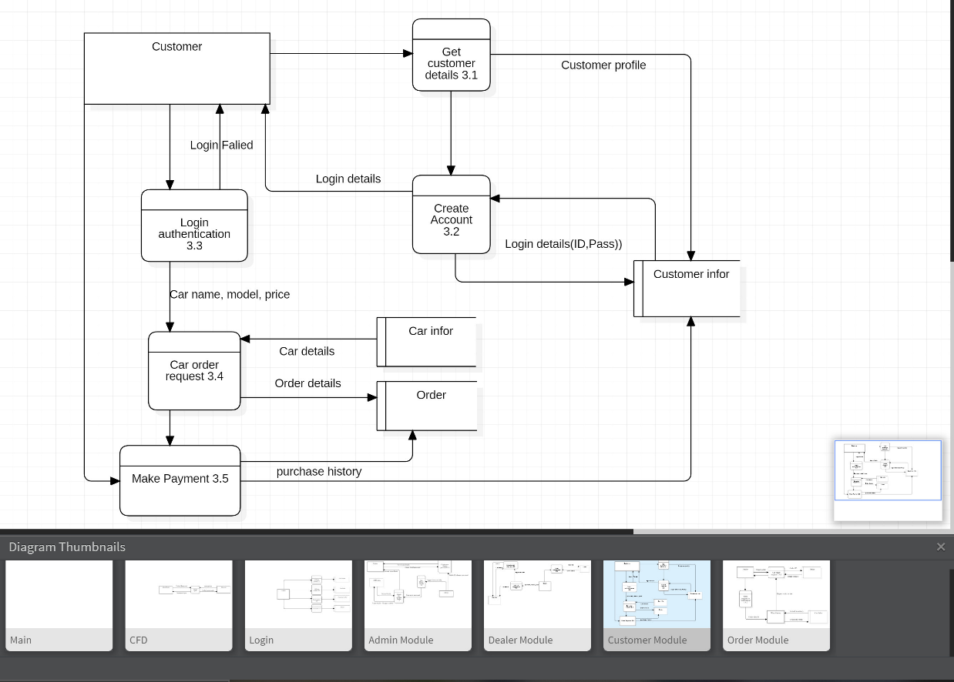

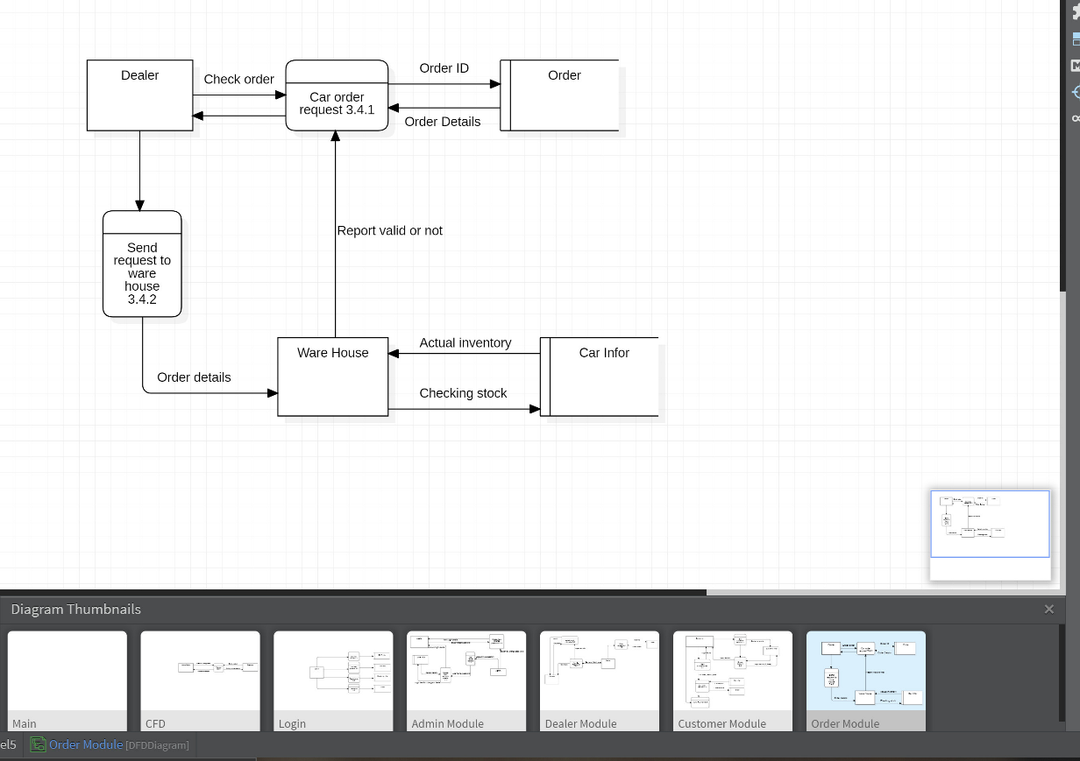**3.6 Order Module**

**REVIEW 2 – TASK SHEET**

|  |  |  |  |  |  |
| --- | --- | --- | --- | --- | --- |
| No. | Contents | Member | Activity Plan | Preparation | |
| Start Date | Actual Days | Status |
| 1 | Login | Nguyễn QUốc Khang,Huỳnh Thành Phát, Lê Anh Trung, Đinh Toàn Thịnh | 10/02/2022 | 27/02/2022 | Done |
| 2 | Customer Profile |
| 3 | Car Detail |
| 4 | Car Compare |
| 5 | System Requirements |
| 6 | Manage Admin |
| 7 | Data Flow Diagram |

**REVIEW 3**

**1. Client’s Side**

**1.1 Home**

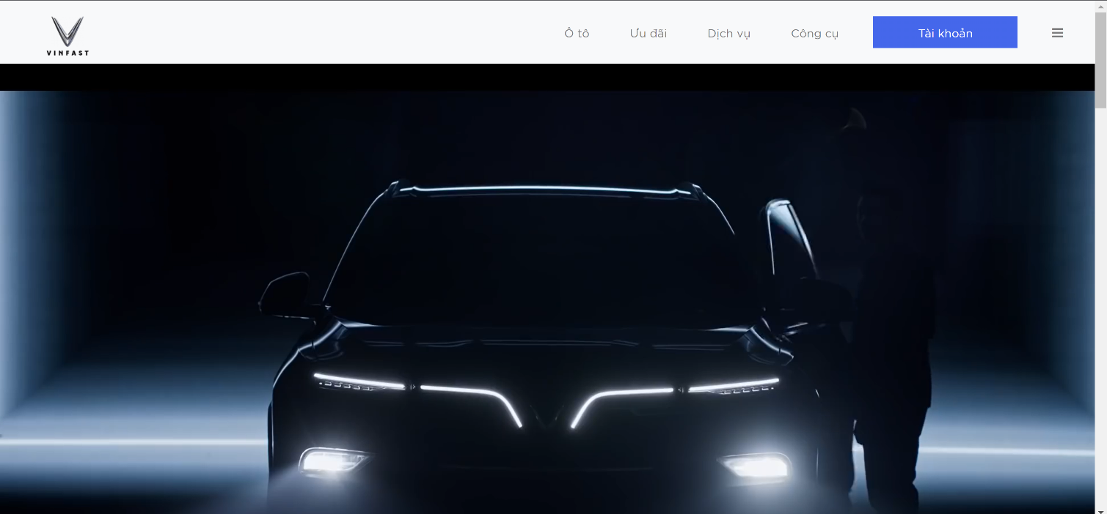

|  |  |
| --- | --- |
| Description | Home page |
| Connect From | N/A |
| Connect To | Login page, Products page, Contact us, Shopping Cart, Search |
| Validation | N/A |
| Initial Values | N/A |
| Events | - Navigate the website by clicking on menu items or products. |
|  |  |

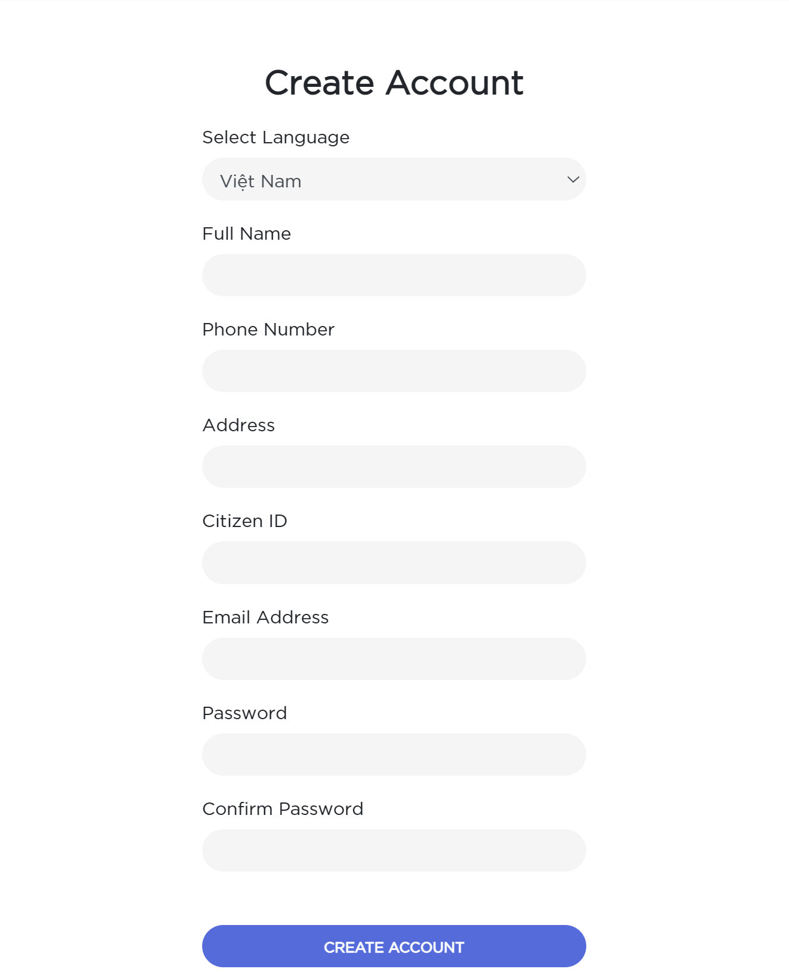**1.2 Register**

|  |  |
| --- | --- |
| Description | Guest signs up for new account |
| Connect From | Home |
| Connect To | Login page, Home |
| Validation | - All fields: not blank  - First name & last name: must be not contains special characters - Username: must be unique - Email: must be valid email format  - Password: must be between 6 to 20 characters - Confirm password: must be the same as password |

**1.3 Login**

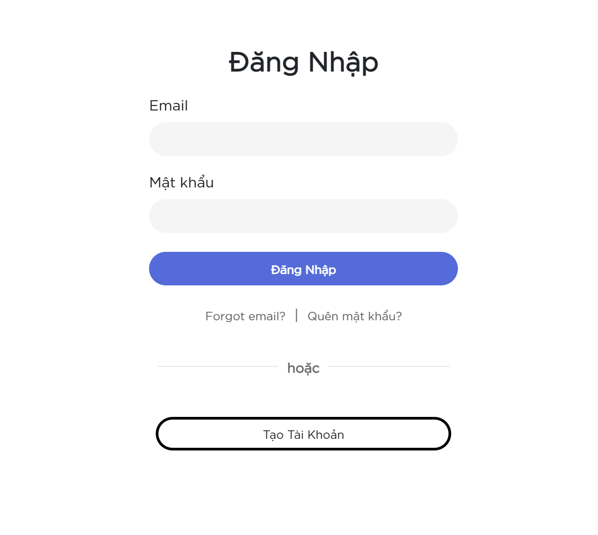

|  |  |
| --- | --- |
| Description | Login with email and password |
| Connect From | Home |
| Connect To | Customer’s profile |
| Validation | All fields: not blank - Email: must be valid email format - Password: must be more than 6 characters  - Email & Password must be the same with database |
| Initial Values | N/A |
| Events | - When click button "Login", check email and password, then login. Login success, go to profile page - When click "Forgot Your Password?" link, go to Forgot password page |

**1.4 Customer Profile**

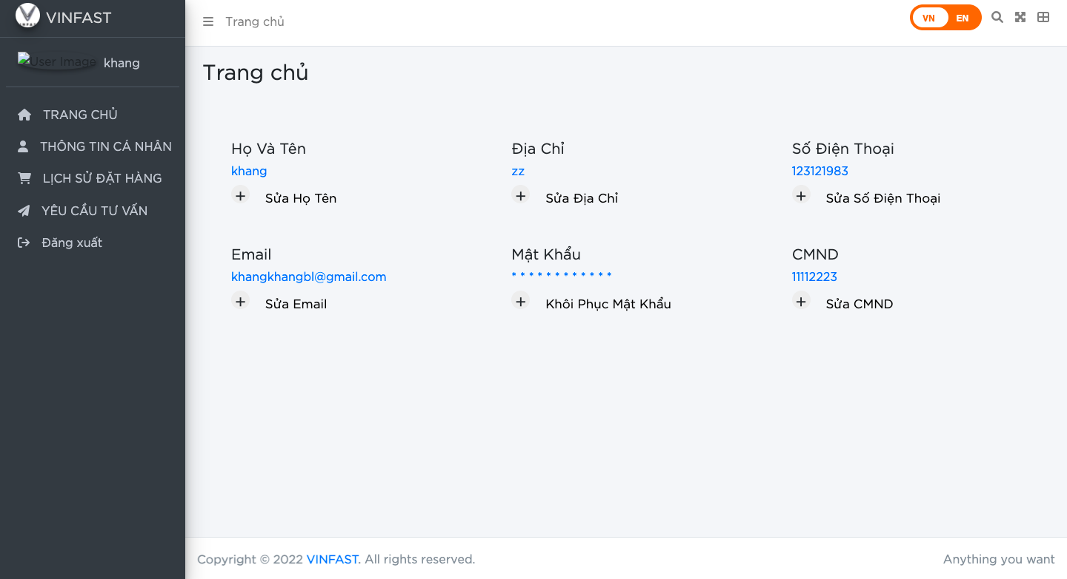

|  |  |
| --- | --- |
| Description | Customer Profile page, customer can see their profile in this page. |
| Connect From | Login page |
| Connect To | Customer’ s order history, order… |
| Validation |  |
| Initial Values | N/A |
| Events | - When click button "edit",they can update their own infomation. Have side bar to choose others funstion. |

**1.5 Profile update**

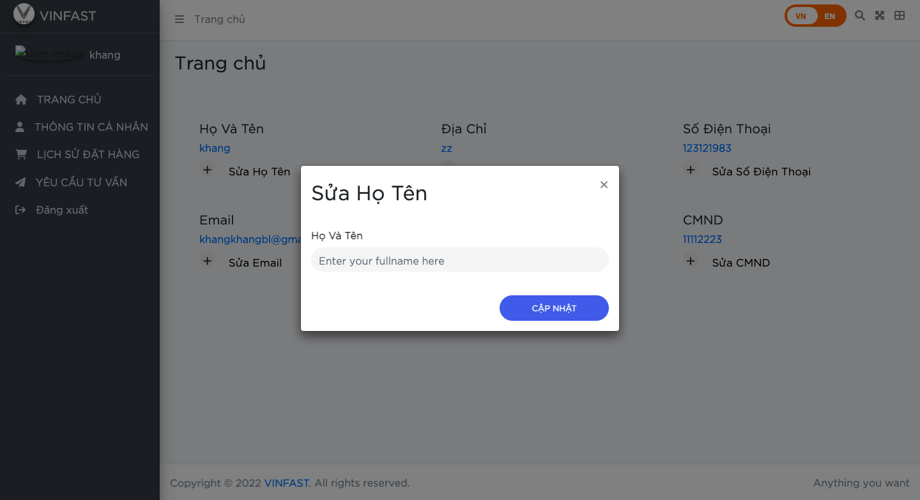

**1.6 View expected Price**

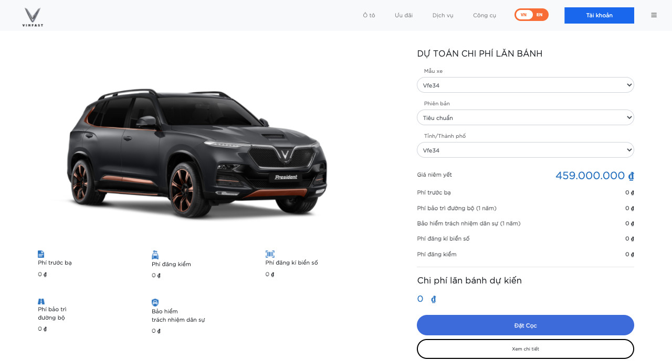

|  |  |
| --- | --- |
| Description | View expected price |
| Connect From | HomePage, Navigation Bar |
| Connect To | Deposit, Car’s Details |
| Validation | N/A |
| Initial Values | N/A |
| Events | -Customer can choose model’s car, Version, Province then system will show expected price with all fees. - Click Deposit go to Deposit Page.  - Click View Detail go to View Detail of that car. |

**1.7 Compare product**

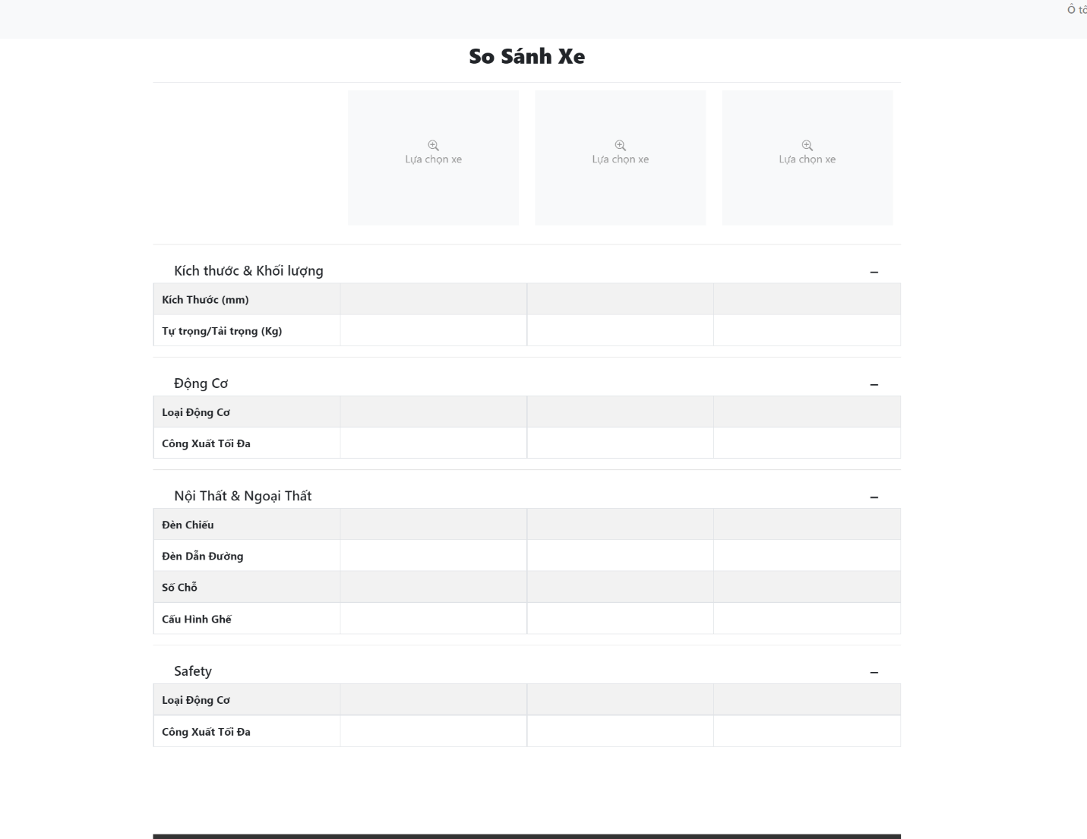

|  |  |
| --- | --- |
| Description | Compare products |
| Connect From | Dashboard |
| Connect To | Model_infor |
| Validation | N/A |
| Initial Values | N/ |
| Events | -When the user selects the magnifying glass icon, a list of vehicles to compare is displayed |

**2. System Side**

**2.1 Amin login**

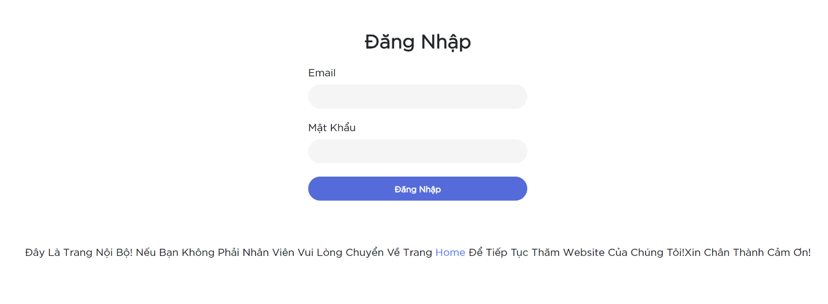

|  |  |
| --- | --- |
| Description | Login with email and password |
| Connect From | N/A |
| Connect To | Admin home |
| Validation | All fields: not blank - Email: must be valid email format - Password: must be more than 6 characters  - Email & Password must be the same with database |
| Initial Values | N/A |
| Events | - When click button "Login", check email and password, then login. Login success, go to admin home page |

**2.2 Create a new employee account**

|  |  |
| --- | --- |
| Description | Super admin create new account |
| Connect From | Employee manage |
| Connect To | Employee manage |
| Validation | - Email: must be valid email format  - Password: must be between 6 to 20 characters - Confirm password: must be the same as password  -Role choose selectbox.  If role is ‘dealer’ , branch is avalable |
| Initial Values | N/A |
| Events | When click in ‘Tạo mới’ in employee manage page, redirect to create form.Only Super admin can use it. |

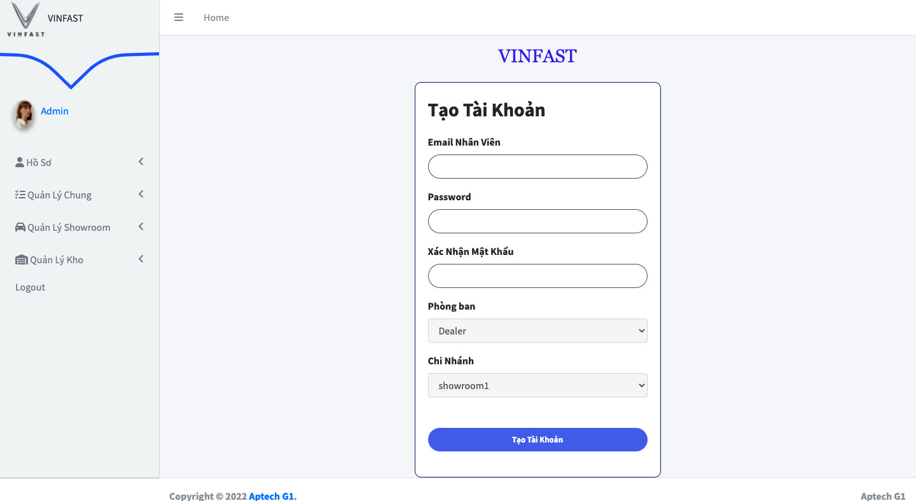

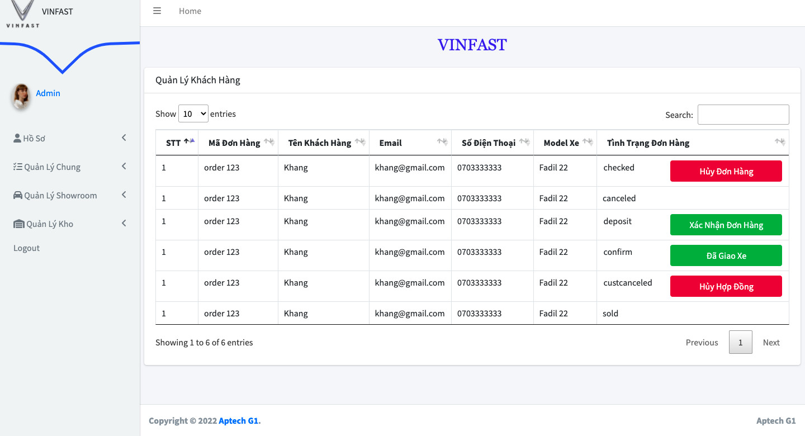**2.2 Customer manager**

|  |  |
| --- | --- |
| Description | Super admin can see list off Customer |
| Connect From | Admin General page |
| Connect To | N/A |
| Validation | N/A |
| Initial Values |  |
| Events | When admin click in ‘Quản Lý Khách Hàng’ in General page. Show a customer manage page |

**2.3 Employee manager**

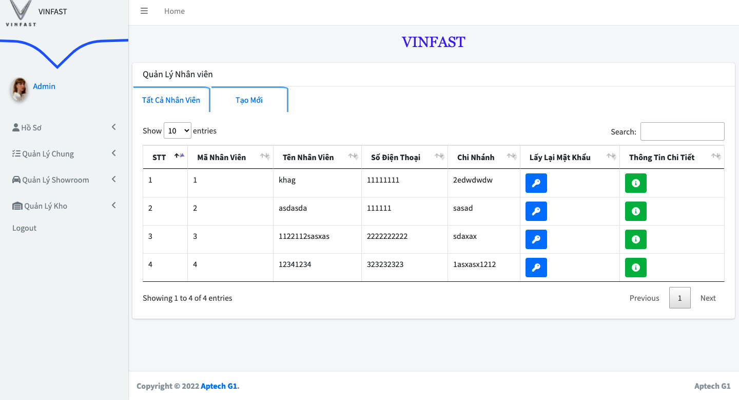

|  |  |
| --- | --- |
| Description | Super admin can see and manage employee.Change employee password, see detail |
| Connect From | Admin general page |
| Connect To | N/A |
| Validation |  |
| Initial Values |  |
| Events | When admin click on ‘Quản lý nhân viên’ admin can see list of employee. |

**2.4 Order management**

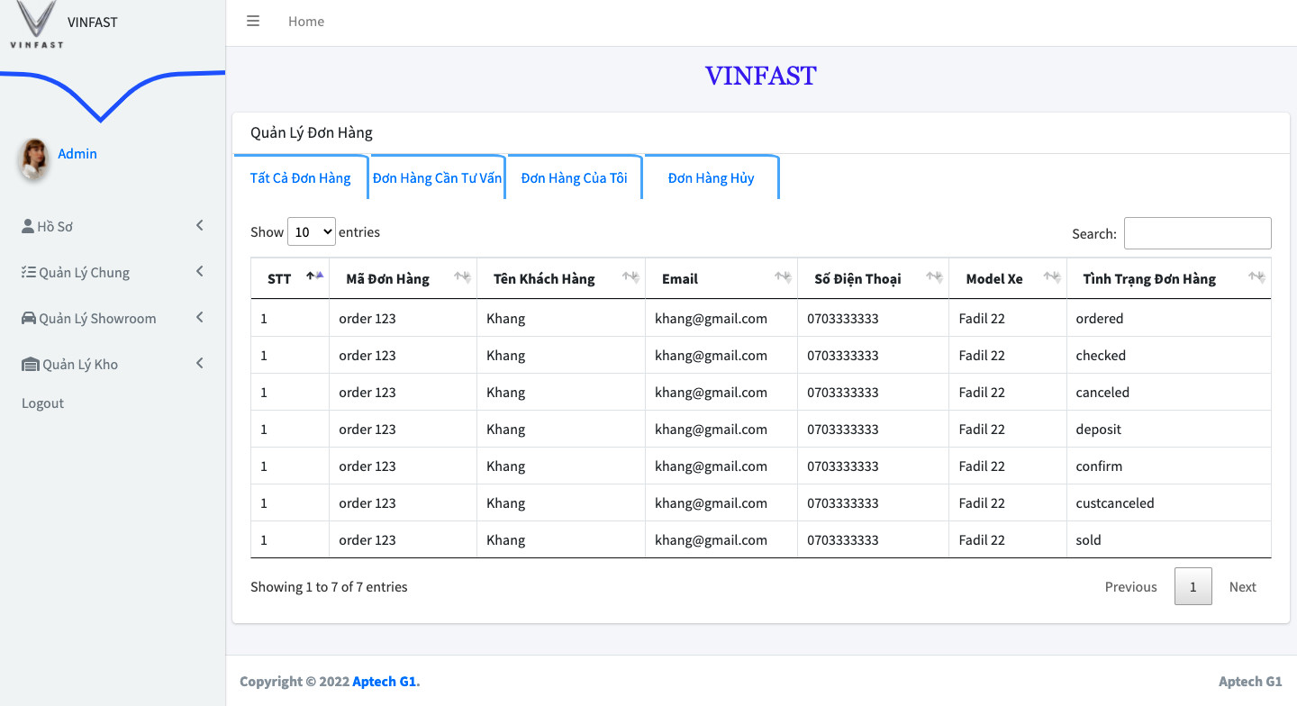

|  |  |
| --- | --- |
| Description | Emloyee can see list of orders folow there status, thay can manage orders. |
| Connect From | Showroom manage page. |
| Connect To | N/A |
| Validation | N/A |
| Initial Values | N/A |
| Events | When admin click on ‘Quan lý đơn hàng’ in showroom manage page, they can see list of order folow status. |

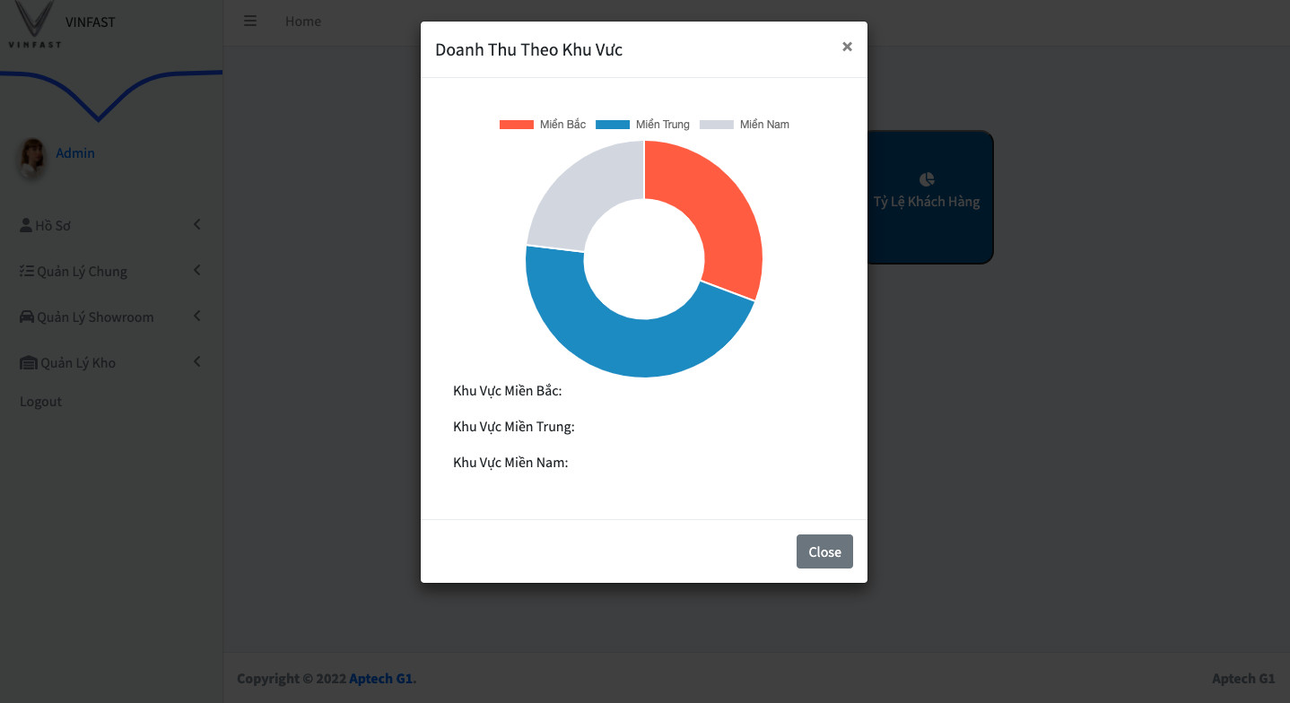**2.5 Report**

|  |  |
| --- | --- |
| Description | Admin can see some report about company business. |
| Connect From | General manage page |
| Connect To | N/A |
| Validation |  |
| Initial Values |  |
| Events | When admin click on ‘Report’ in general manage, thay can see some option of report.Click them to see charts as a modal. |

**2.6 Warehouse manage.**

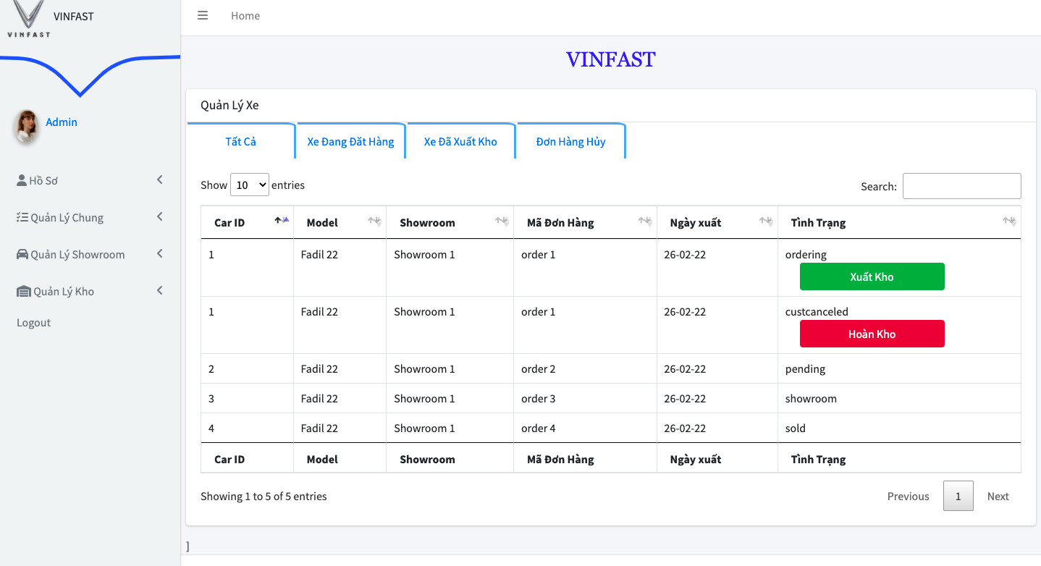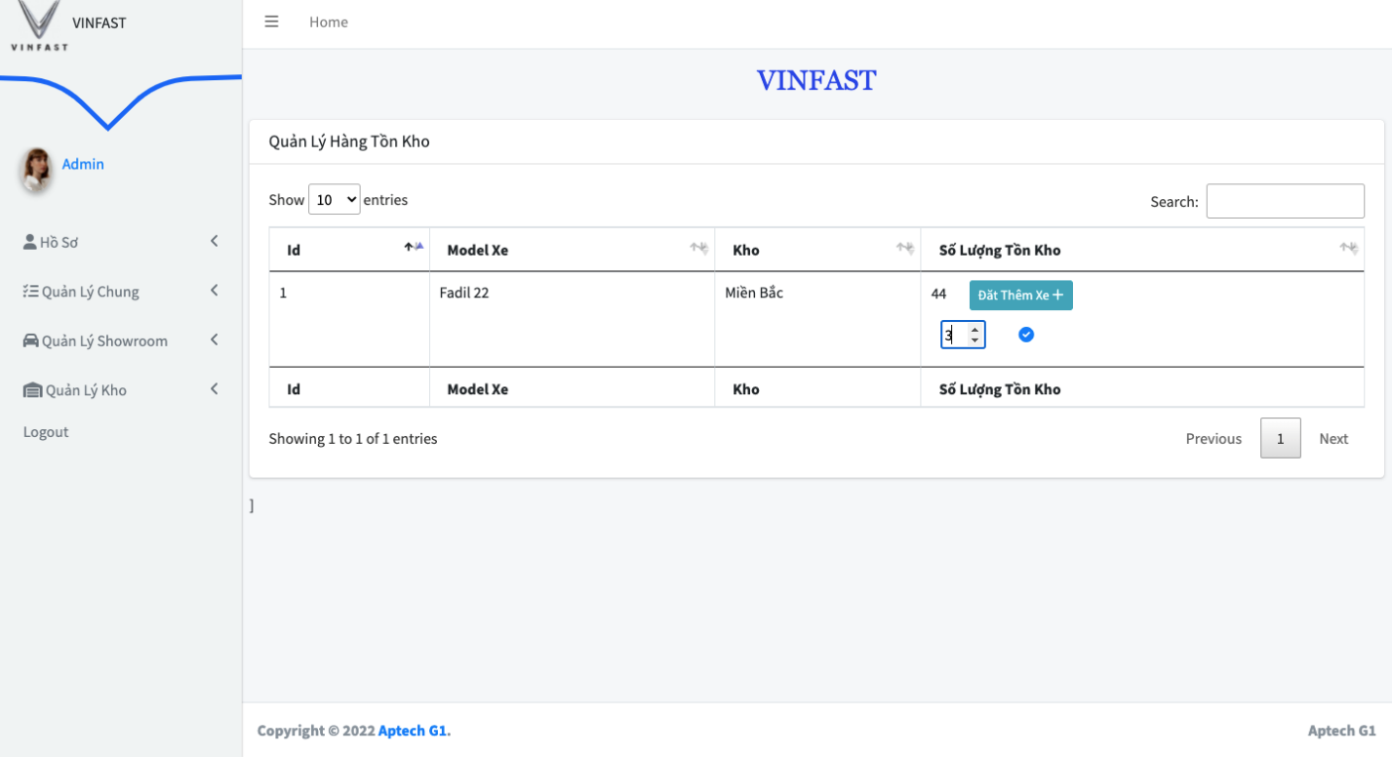

|  |  |
| --- | --- |
| Description | Admin can manage warehouse:Stock and car release. |
| Connect From | warehouse manage page |
| Connect To | N/A |
| Validation |  |
| Initial Values |  |
| Events | When admin click on ‘warehouse’ in admin homepage or menu, they can see list of option to manage warehouse: manage car folow status or can manage stock(add more stock ) |

**2.7 Create car model.**

|  |  |
| --- | --- |
| Description | Admin can add new car model with all attributes. |
| Connect From | general manage page |
| Connect To | N/A |
| Validation |  |
| Initial Values |  |
| Events | When admin click on ‘create a new model’ they can create new car model. |

**2.8 Update car model.**

|  |  |
| --- | --- |
| Description | Admin can update car-model’s attributes. |
| Connect From | general manage page |
| Connect To | N/A |
| Validation |  |
| Initial Values |  |
| Events | When admin click on ‘update’ button, they can update car-model’s attributes. |

**2.9 Delete car model.**

|  |  |
| --- | --- |
| Description | Admin can delete a car model |
| Connect From | general manage page |
| Connect To | N/A |
| Validation |  |
| Initial Values |  |
| Events | When admin click on ‘delete’ button, they can delete car model. A popup modal will be shown to confirm if admin click the button by accident. |

**2.10 Search car model.**

|  |  |
| --- | --- |
| Description | Admin can search car model |
| Connect From | general manage page |
| Connect To | N/A |
| Validation |  |
| Initial Values |  |
| Events | When admin input into search field a string, system will show the result which match the search string. Admin can search by model id and model name. |

**REVIEW 3 – TASK SHEET**

|  |  |  |  |  |  |
| --- | --- | --- | --- | --- | --- |
| **No.** | **Contents** | **Member** | **Activity Plan** | **Preparation** | |
| **Start Date** | **Actual Days** | **Status** |
| **Client** | | Lê Anh Trung | 10/02/2022 | 10 | Completed |
| 1 | Homepage |
| 2 | Customer Login |
| 3 | Customer register |
| 4 | Customer Profile |
| 5 | View expected Price |
| 6 | Admin page | Nguyễn Quốc Khang | 10/02/2022 | 10 | Completed |
| 7 | Admin login page |
| 8 | Genaral manage:  -Report  -Employee manage.  -Customer manage. | Nguyen Quốc Khang | 10/02/2022 | 10 | Completed |
| 9 | Showroom manage:  -Order manager:  -Car manage. | Nguyễn Quốc Khang | 10/02/2022 | 10 | Completed |
| 10 | Ware house manage:  -Car manage.  -Stock manage. | Nguyen Quốc Khang | 10/02/2022 | 10 | Completed |
| 11 | Admin Profile |  | 10/02/2022 | 10 | Completed |
| 12 | -Model manage pages | Huynh Thanh Phat | 10/02/2022 | 10 | Completed |
| 13 | Car detail | Pending |
| 14 |  |  |
|  | | | | | |
| **Client** | | Dinh Toan Thinh | 10/02/2022 | 10 | Completed |
| 15 | Compare page |
|  |  |
|  |  |
|  |  |
|  |  |  | 10/02/2022 | 10 | Pending |
|  |  |  | 10/02/2022 | 10 | Pending |
|  |  |
|  |  |
|  |  |  |  |  |  |
|  |  |
|  |  |
|  | | | | | |
| **Client** | |  |  | 10 |  |
| 1 |  |
| 3 |  |  |  | 10 |  |
| 4 |  |  |  | 10 |  |